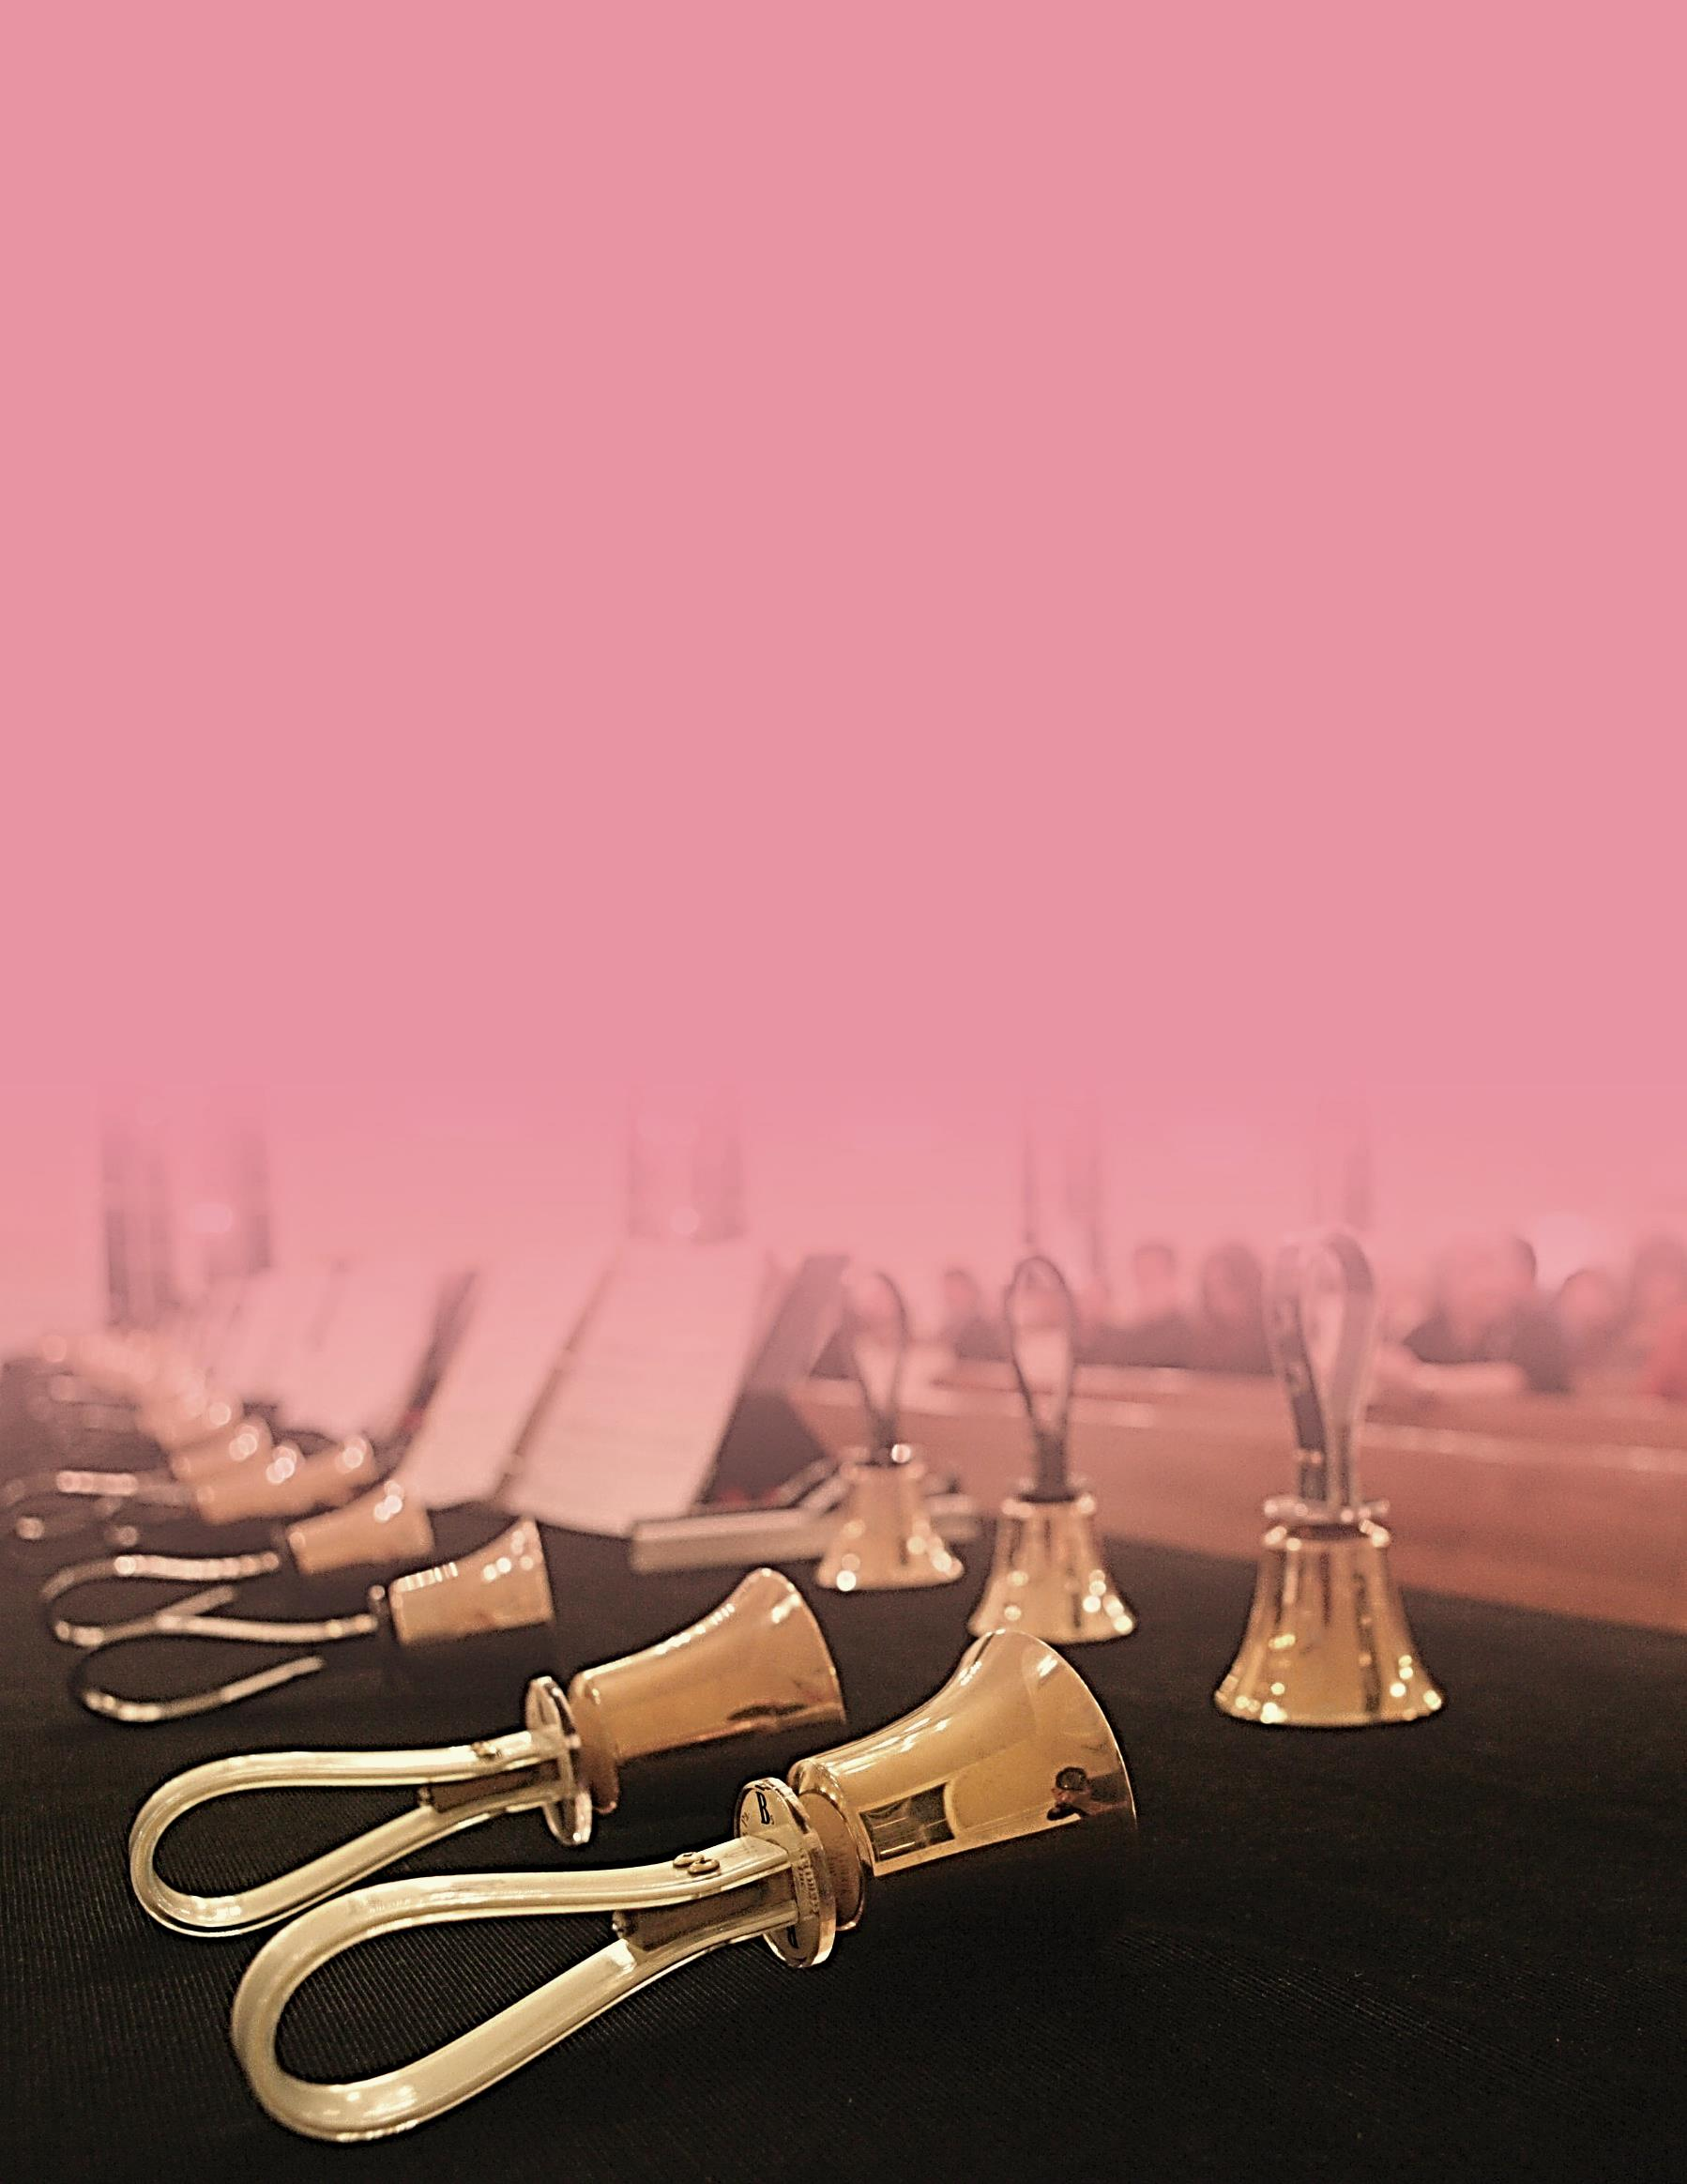

**May 19th, 2019   
Sunday 4:00 p.m.**

**Campbell United Methodist Church**

Handbell

Concert

**Campbell United Methodist Church  
1675 Winchester Blvd  
Campbell, CA 95008**(408) 378-3472  
www.campbellunited.org

**FREE ADMISSION**