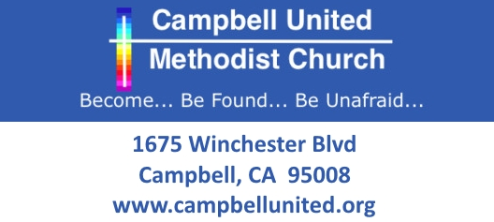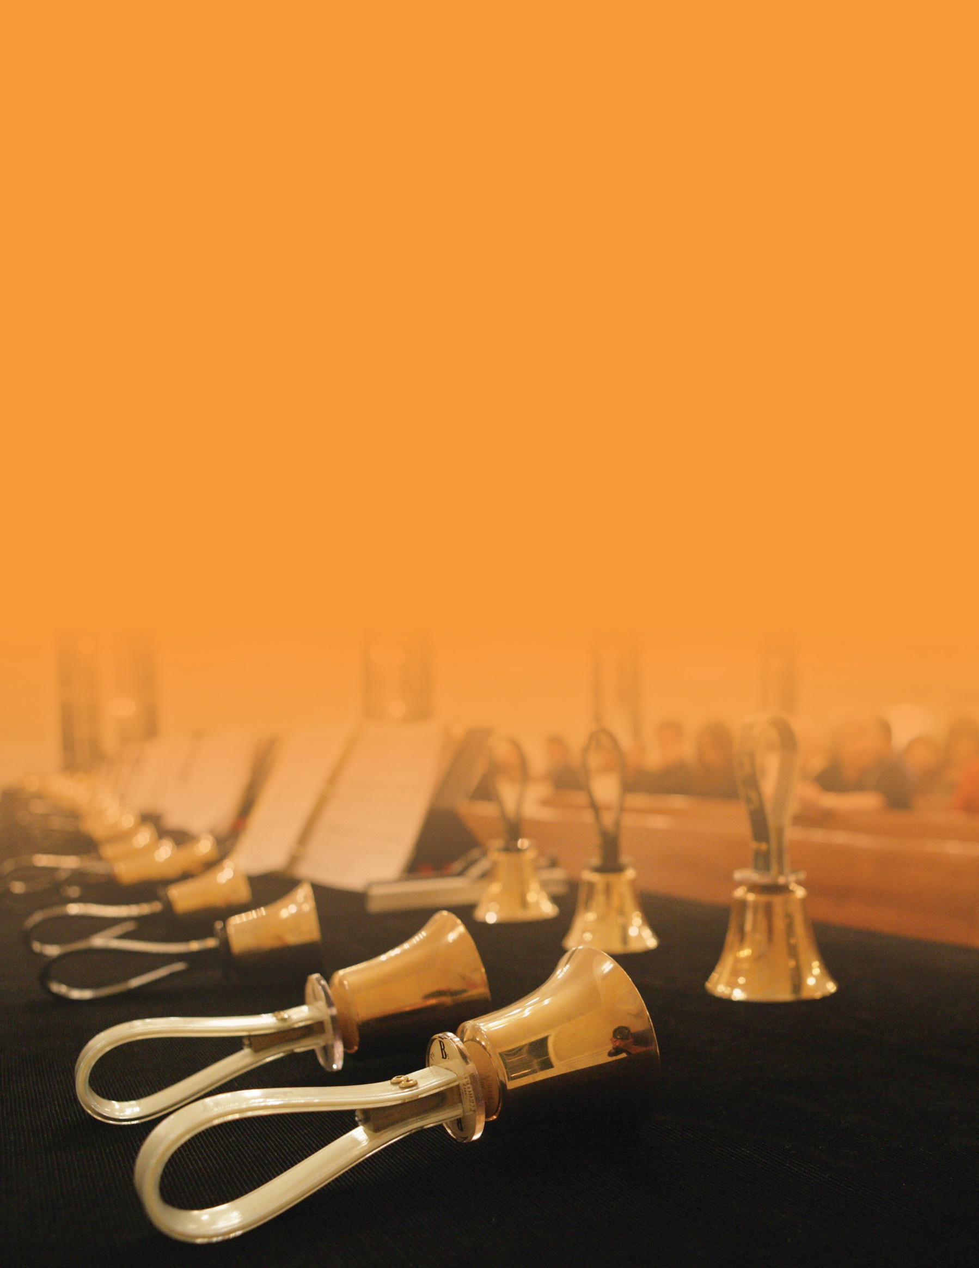

**May 21, 2017   
Sunday 3:30pm**

**Featuring4 Handbell Groups, adults and children**

**FREE ADMISSION**

Campbell United Methodist Church  
1675 Winchester Blvd  
Campbell, CA 95008  
(408) 378-3472  
www.campbellunited.org

**Handbell Concert**