**You are invited to**

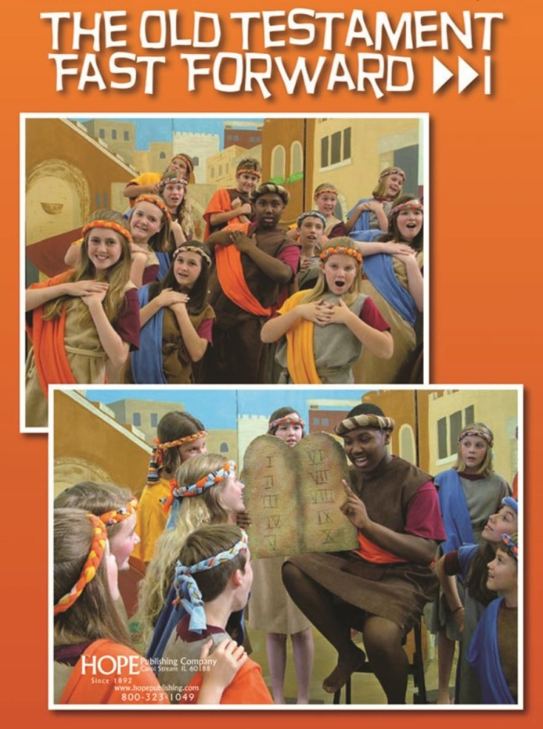

**Campbell United  
Methodist Church’s  
Annual Children’s Musical:**



**Sunday, May 5th, 2019**

**Performances at:**

**10:00am and 2:00pm**

Come see the fun and inspiring Children’s Musical Presentation as we experience the old stories of love, forgiveness, courage, and promise in the musical,   
"The Old Testament Fast Forward" by Tom S. Long & Allen Pote.

This amusing 45-minute "attempt" to present the Old Testament begins with a promise to cover the entire history in ten minutes. Needless to say, they don't get all the way through - even after revising their estimate to twenty, then thirty, then forty minutes - but there's plenty of humor and moving moments as the kids  
encounter the lessons and eternal truths found within the stories of   
Adam & Eve, Noah, Moses, David and many more.

***The whole community is invited - Share with Friends and Neighbors! ALL are Welcome!***

**www.facebook.com/events/427468331132016**



**Campbell United Methodist Church**

**1675 Winchester Blvd**

**Campbell, CA 95008**

[**www.campbellunited.org**](http://www.campbellunited.org/)